Goblins. Specifically a clan of goblins called Clan Pook, who lived in the sewers beneath the city. They spend their time collecting treasures they find within and without the sewers and bring them to Kerkyra, the clan ‘broodmother’.

Kerkyra is actually, unbeknownst to the clan, an aberration. It is specifically what is called a Skum, a servant of an ancient aberration that existed long before the Gods, an aboleth, which is the true Kerkyra that speaks to the clan through this Skum. It is using & influencing the clan to search the city for an artifact called Splendarrwurn (dwarvish for Shining Water). It is a alexandrite diadem with a pure mithril crescent affixed to its center. The crescent itself is what Kerkyra is after. It is one of a trinity of items she is seeking, called the Tridacna: a trio of keys that, when gathered in the correct spots, will open the portal that holds her in a pocket dimension of the Elemental Plane of Water. She was sealed there by the Gods in ancient times.

The other two keys are as follows: The Pearl of the Tridacna (the last surviving pearl of a giant clam called Abyssus) and the Giridoshi Sphere (a vantablack sphere that appears flat from all angles and has a glowing ring around it, resembling an eclipse. It is an artifact that is said to have been created when a giant squid drew too curiously to the surface and looked upon the eclipse and its eye rolled over, imbued with the power of the eclipse. If you look at the sphere, it will cause blindness, making it extremely difficult to find)

One day, a hoard of cranium rats attacked the clan in the sewers in the dead of night (having been sent there by the aboleth for the goblin’s continued failure), causing mass panic in the dark. Multiple clan members were lost & the clan had to flee. Min was separated from the group and found her way to the surface through a small pipe that exited on the outskirts of the city, draining into a nearby wood.

While trying to find her way, she stumbled upon an old druid who was in the midst of containing a wild magic event. She ended up distracting the druid, and the wild magic was for but a moment unleashed. It latched upon Min, and coursed through her body, before the druid was able to gain a hold of it again. It was too late, however, and she had transformed into a beast. A giant rat. In fear, panic, and confusion, Min fled back into the sewers and eventually found her clan after a week of searching in this rat form.

Min was expecting a warm welcome, but when they saw her rat form they were horrified & disgusted. They considered her new form a reflection her allegiance, and was cursed for betraying her family. (In truth they were willed to believe this by the aboleth, who realized that the wild magic event had severed her hold over Min. This is because Min was now a Druid of the Moon & the aboleth was sealed away by the powers of the goddess of the moon). Min then was finally given her name (she had thus far been called Tress, for her hair) which was Abomination (or Min for short). She was then exiled for life and chased out of the sewers. Her father was heartbroken.

Min returned to the forest in hopes of observing some way to reverse the magic, still stuck in her giant rat form. The druid saw the giant rat watching from the bushes and decided that he would show her how to come out of this rat form & control her powers. After multiple attempts she was able to reverse the way she looked. In joy and elation she went back home & was heartbroken when the clan still rejected her.

So, once again she turned back towards the forest. Over the next few weeks, she observed the druid from afar as he did his magic, learning how to control her powers. (The druid in truth was well aware she was watching, and coyly played along). Eventually, he approached and gave his name: Emér. He taught min about the moon, the forests, and the gods whose will is of the wood, water, and earth. Emér was veeeery old, with a beard that trails behind him as he walks, but shockingly spry for his age. She watches him as each and every night he goes out and watches the moon as if she were an old friend.

(Backstory for Emér, Min does not know this information): While his age is not known, he is extremely old. When he was a boy, he was wandering through the wood as was typical at twilight. On this night he was full of sorrow for he had lost his mother forever. In desperation, he looked at the moon, cried, and wished for his mother to be kept safe. The moon goddess was so moved by his plea that she spoke to him. When he heard her voice it was like he was seeing light for the first time. She said that her light would never stop shining upon the grave of his mother, and would always protect him. He then promised that he would devote himself to the moon goddess until the end of his life, which has proved to be unnaturally long. The moon goddess decided to give him power. The power she bestowed upon him were not known to him until her figure appeared and pressed her finger to his forehead and he lost his vision. She said “Be not afraid, I give you that which is precious to me.” And then he opened one of his eyes. Through this eye the world looked like it was encased in moonlight, so it always looked like a moonlit night. The other eye he could never open again. Then she said, “Keep that which I have given you secret. It is more precious than you know. You will always be able to see me, when your need is greatest.” And then she disappeared into the moon. (In his open eye he has the luminescent Pearl of the Tridacna and in his closed eye he has the black-glowing Giridoshi Sphere).

(Back to what Min knows) After months of training, Min had an epiphany and realized that if she found one of the items (the Diadem) she would be able to curry favor with the Broodmother Kerkyra and Cheef Bogtrog and be welcomed back with open arms. That is why she has returned to the city, searching for the diadem Splendarrwurn and heard that rich people live in the cities.

Abomination, “Min” or Tress

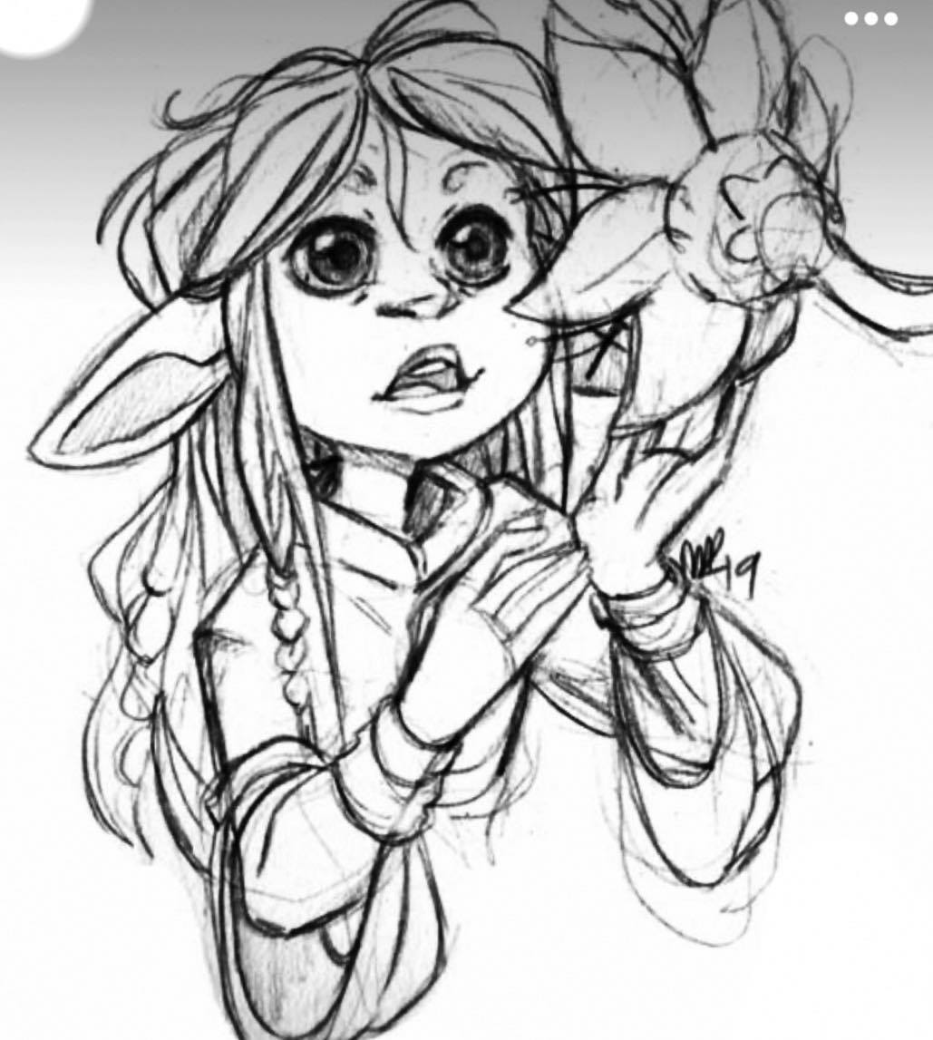

Cheef Bogtrog

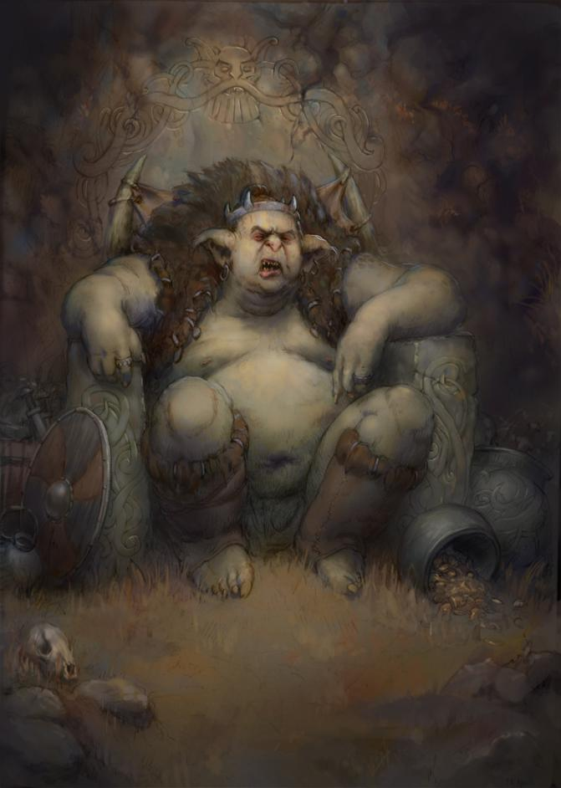

Emér

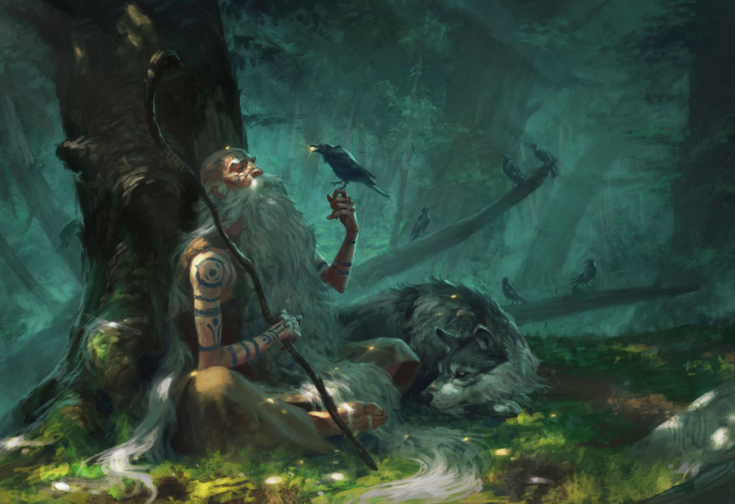

Kerkyra the Aboleth

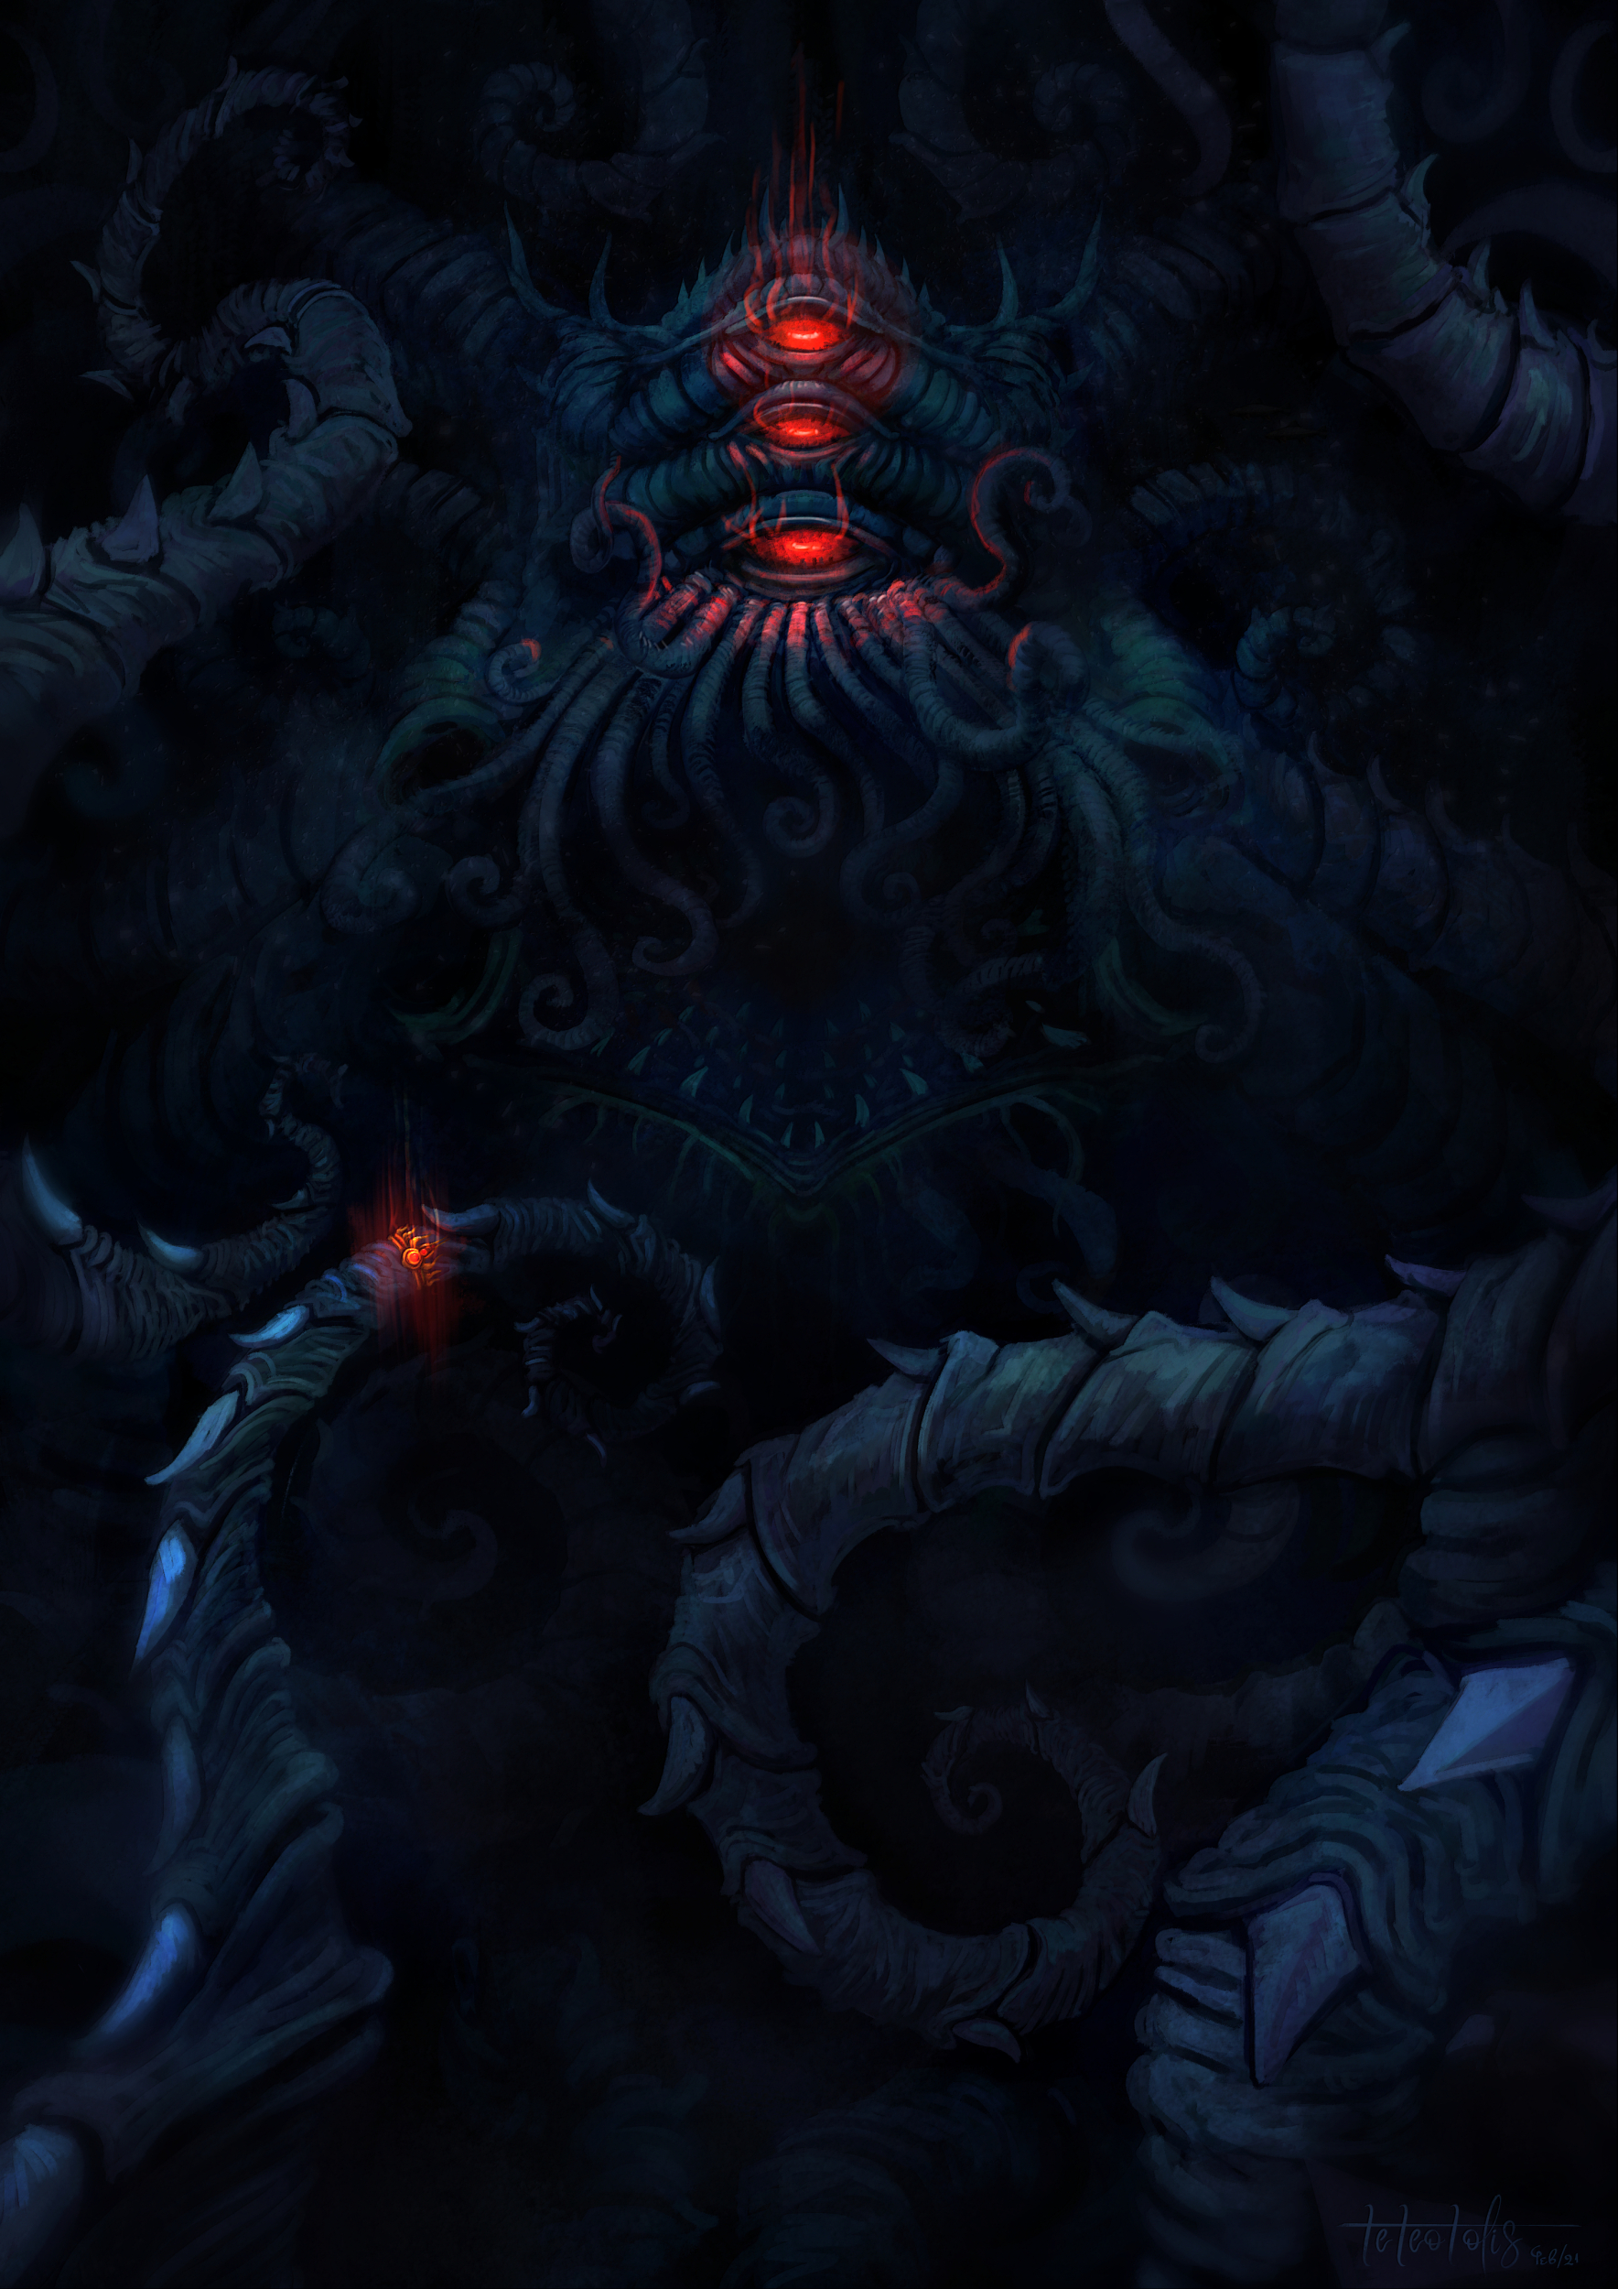

Broodmother Kerkyra (Skum Servant)

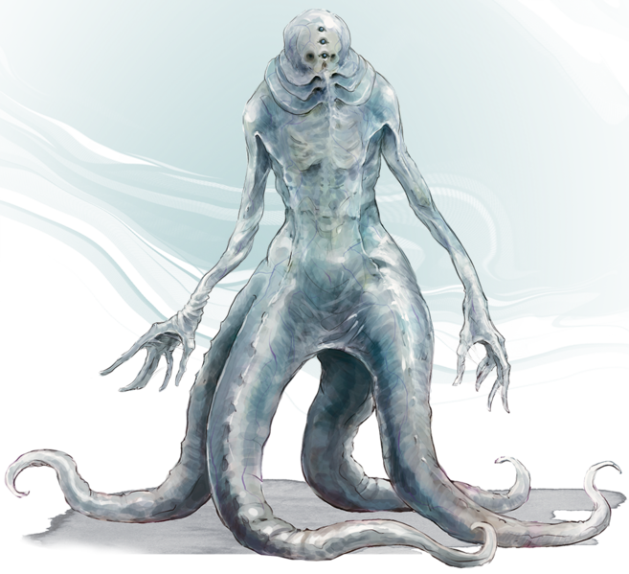

Information on Clan Pook

* Cheef Bogtrog (leader)
  + Big & bulky, gruff & grumpy
  + Illiterate but his powers of perception & wisdom is high for a goblin
  + Alignment: Lawful Neutral
* Panco (Father)
  + Defining moustache
  + Has an affinity for collecting things, scavenges supplies for the clan
  + He is very naive & unwise, but intelligent
  + HATES Ted Baker, rival tinkerer
* Kerkyra (Aboleth Broodmother, Skum Mouthpiece for true Aboleth master)
  + Gluttonous, vain, & mean
  + Emotionless & manipulative, immense intelligence
  + The only reason people put up with her is because they fear her & are telepathically willed by her
    - Aboleth master below, older than the Gods
    - In primordial times she was sealed in a pocket dimension of the Elemental Plane of Water whose locked portal is deep under the city
    - Using the Clan to gather keys to her escape
      * Pearl of Tridacna (Pearl of a giant clam called Tridacna, Sphere)
      * Splendarrwurn (Dwarvish for Shining Water, it is a Pure Mithril Crescent Jewel on an Alexandrite Diadem, Dwarven)
      * The Giridoshi Sphere (Vantablack Sphere that appears flat from all angles & has a glowing ring around it, resembling an eclipse. It is an artifact that is said to have been created when a giant squid drew too curious and ventured too close to the surface and looked upon an eclipse. If you look at it, it will cause blindness, making it extremely difficult to find.)
      * They need to be gathered at the Ultok (Meeting Place)
* Abomination, “Min” (Megan)
  + Really, really big ears
  + Very light blonde hair
  + Pure black eyes
* Ritten & Gash (twins, younger siblings)
  + Ritten is tall & Gash is short (for goblins)
  + Conjoined, Ritten has most of the mobility
* Ted Baker (gnome foundling, tells her about the outside world)
  + Tinkerer, always at odds with Panco since he’s a better tinkering
  + Very exciting to the goblins, everyone likes & admires him
  + He can be a bit of a dick, he’s pretty into himself
* Poosha
  + Close friend of Min
  + Meek, sickly, & very, veery small
  + Nervous, but very kind
* Warthog
  + Close friend of Min
  + Chunky, funny, & adores food
  + Has a concerning number of warts…everywhere
* Pikkel
  + She is very maternal & knits w/ hair found in the sewer drains, but is very good at her craft
* Teeto
  + The fun uncle…the funcle
* Jik
  + Struggles with a gambling addiction, and is a swindler, but he tells really good jokes
* Yempe
  + Cheef Bogtrog’s mother, she is like a grandmother to the whole clan
  + She can’t really open her eyes anymore & has no mobility, so just sits in her chair
  + She is full of wisdom & really, really good rat recipes
* Skintzer
  + The “doctor” of the clan, he is Poosha’s father
  + He thinks he’s smart, but is right only about 40% of the time
* Chunks
  + Really skinny because he throws up a lot; he struggles with undiagnosed bulimia
* Mugniff
  + The clan’s pet rat, used to hunt other rats (a traitor if you will)
  + He likes the taste of rat; struggles with cannibalism
* The Beard
  + Has a beard
* Eemaw (Likes-Naked-People)
  + Weird, mute, & curious. He likes to watch people, so he has an erroneous reputation as a perv but isn’t…I think
* Ratagorsky Dustyevsky
  + Russian, drunk, hates the Bolsheviks, hopes the elves rise up, part of the Dump
  + Rumors that he has seventeen children somewhere, but no confirmation
  + Writing a novel called “Notes from the Underground”
* Chunga
  + Only thing it can say: “Chunga”
  + Gender: “Chunga” ???
  + Species: “Chunga”
  + Looks like a cave-person
  + Wooden Club’s Name: “Chunga”
  + Actually extremely intelligent, but cannot verbalize
* Oscus Ruskis
  + Clan warrior, died bravely fighting a swarm of Cranium Rats while the clan escaped. These rats were secretly sent by the aboleth, Kerkyra, as a punishment for the clan disobeying her wishes
* McRib (bff who)
  + We McFuckin Lost Him (When the cranium rats attacked he ran off and was never seen again, his current status is unknown)
* Sketish
  + Drowned in sewer water trying to escape a swarm of Cranium Rats
* Stankbreff
  + He stank & then died trying to save Sketish who was drowning
* Died-In-A-Pot-Hole
  + He died in a pot hole, eaten by Cranium Rats